Name:- Mayukh Barman Ray

Roll No.:-04 , CSE , 2nd Year

Assignment-1(18-8-2020)

P1>

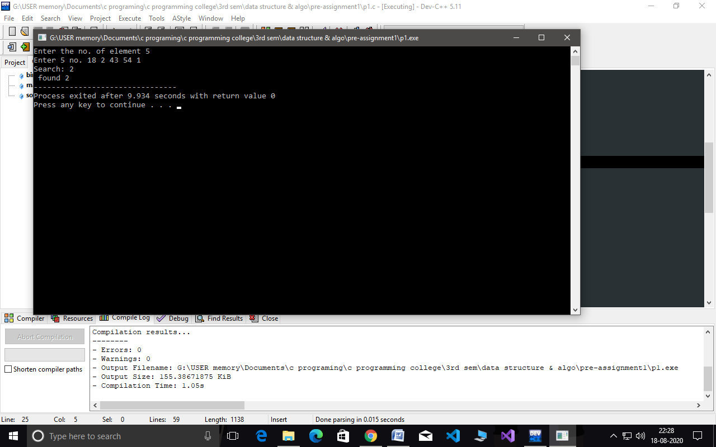

P2>

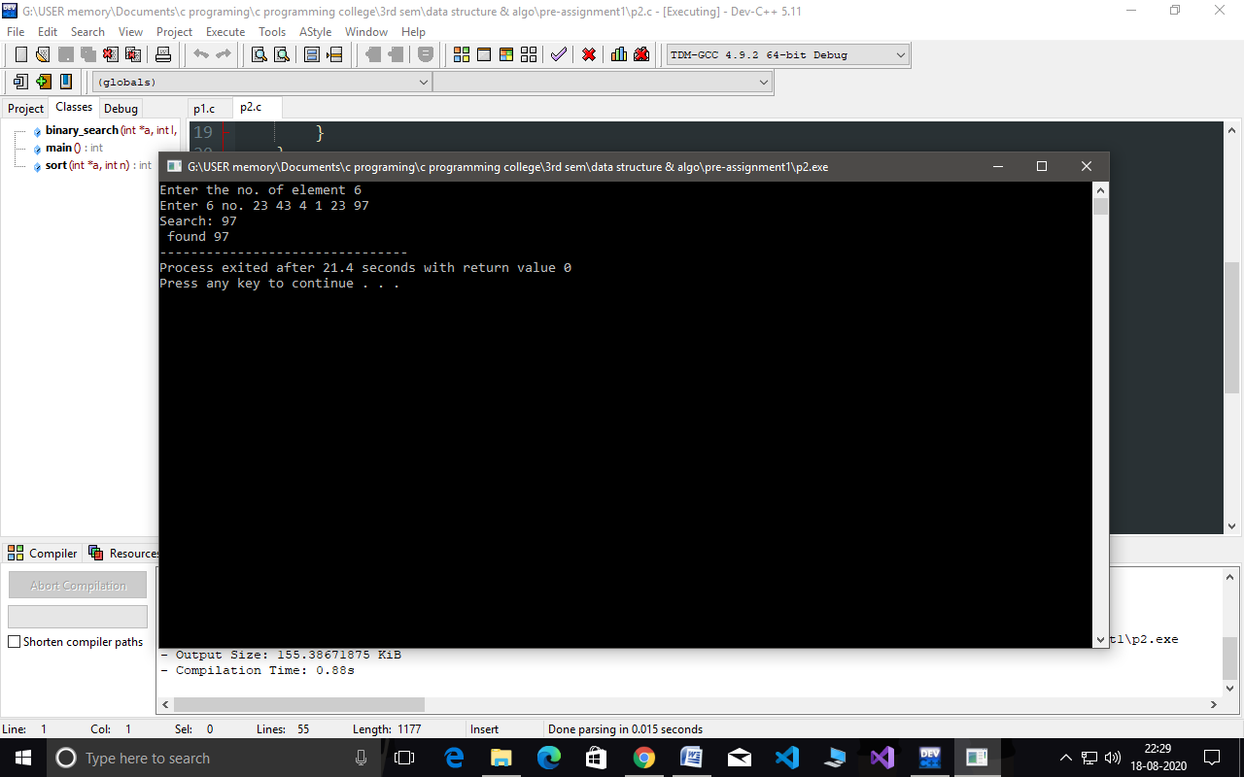

Assignment-2(25-8-2020)

P1>

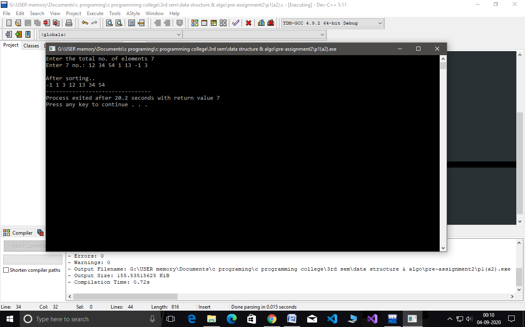

P2>

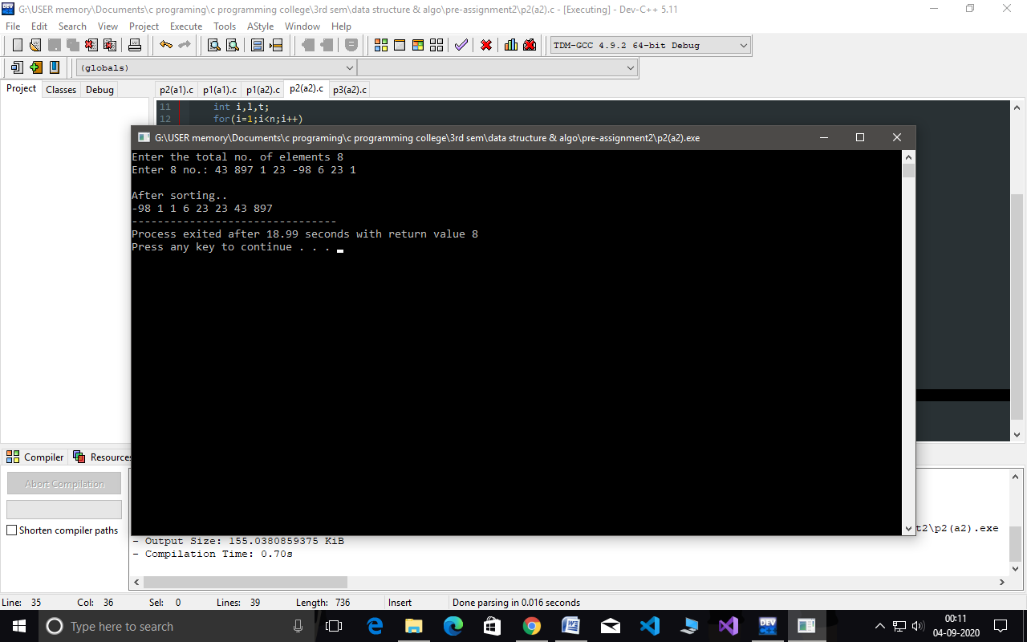

P3>

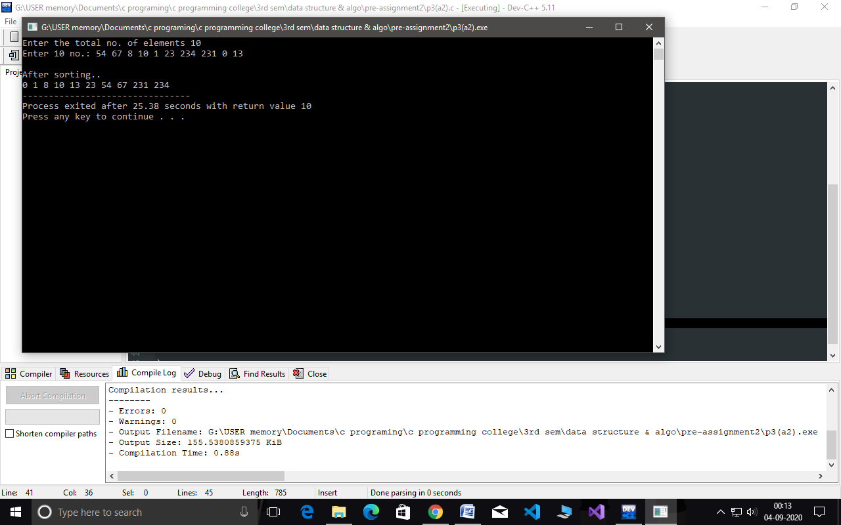

Assignment-3(2-9-2020)

P1>

